Experiment 6
Name: Padma Priya D Roll No: 240701377
AIM:
Simulate the life cycle stages for UI design using the RAD model and develop a small interactive interface using Axure RP.
OBJECTIVE
- To understand the RAD model
- To design user interface screens
- To develop an interactive prototype
- To improve user experience through rapid design
TOOLS USED
- Axure RP 11
THEORY
The Rapid Application Development (RAD) model is a software development approach that focuses on quick development and user feedback.
It consists of four main phases:
- Requirement Planning – Identifying user needs
- User Design – Creating UI layouts and prototypes
- Construction – Developing the working model
- Cutover – Testing and final implementation

RAD is useful for UI design because it allows fast prototyping and easy modifications.
APP NAME
StudyMate – Assignment Management App

RAD MODEL IMPLEMENTATION

1. Requirement Planning Phase

Description
In this phase, the requirements of the application are identified.

Details
- Target Users: Students
- Purpose: Manage assignments and deadlines
- Features:
  - Login system
  - View assignments
  - Add assignments
  - Profile management

2. User Design Phase

Description
UI screens are designed based on user requirements.

Screens Designed
- Splash Screen
- Login Screen
- Dashboard Screen
- Profile Screen

Design Features
- Simple layout
- Easy navigation
- Clean interface

3. Construction Phase

Description
Interactive prototype is developed using Axure RP.

Implementation
- Created pages in Axure RP
- Designed UI elements (buttons, text fields)
- Added interactions using OnClick events

Navigation Flow
- Splash → Login
- Login → Dashboard
- Dashboard → Profile
- Profile → Logout → Splash

4. Cutover Phase

Description
Final testing and evaluation of the prototype.

Testing Done
- Checked navigation between screens
- Verified button interactions
- Ensured smooth user flow

PROCEDURE
- Opened Axure RP 11
- Created a new project
- Added multiple pages (screens)
- Designed UI using widgets
- Added interactions using OnClick events
- Tested the prototype using Preview option
- Splash Screen
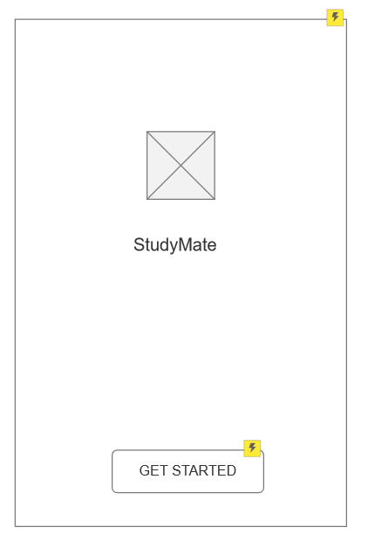
- Login Screen
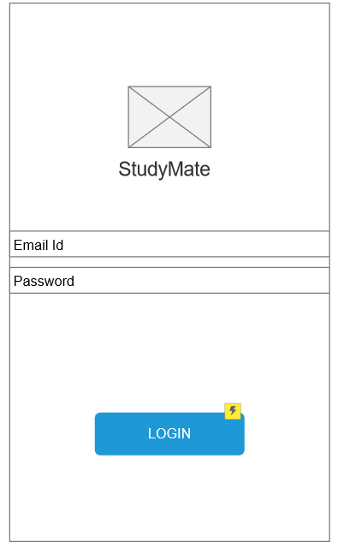

- Dashboard
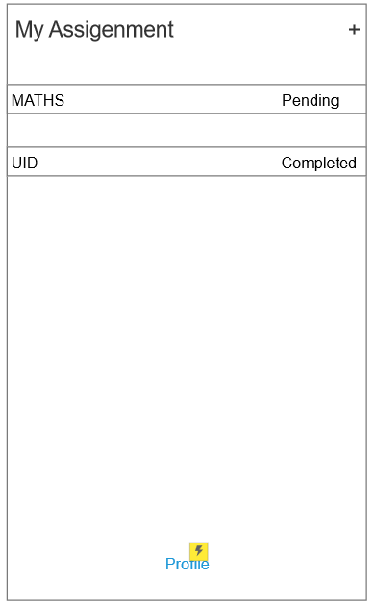

- Profile
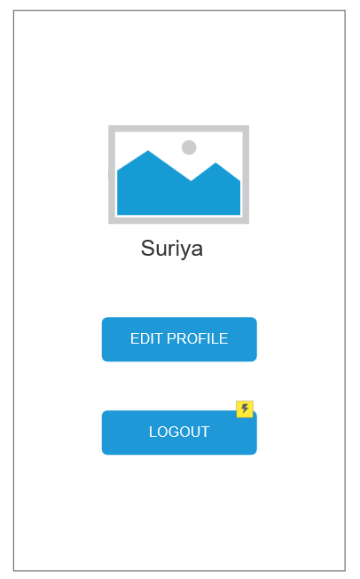

3) Dashboard

